APPLICATION FORM
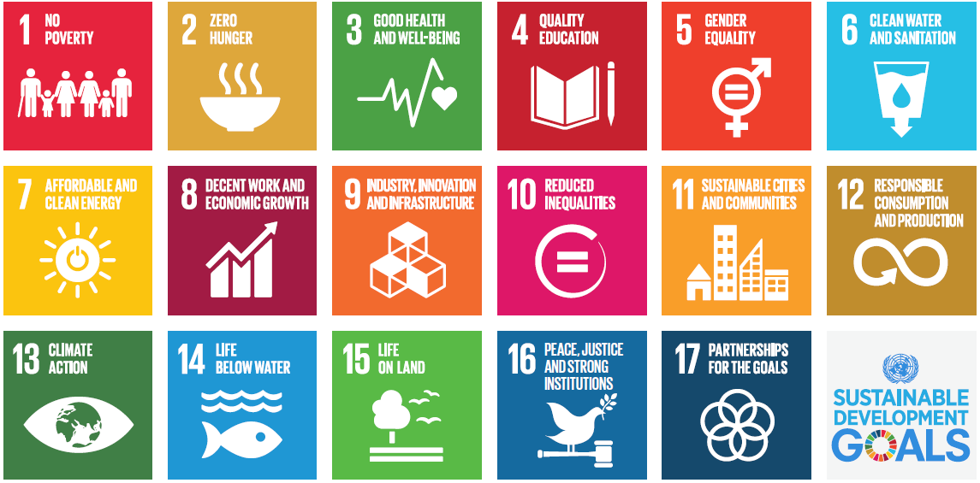
RESEARCH METHODS AND THEIR APPLICATIONS IN SUPPORTING DEVELOPMENT
SEPTEMBER 29 – December 19, 2019

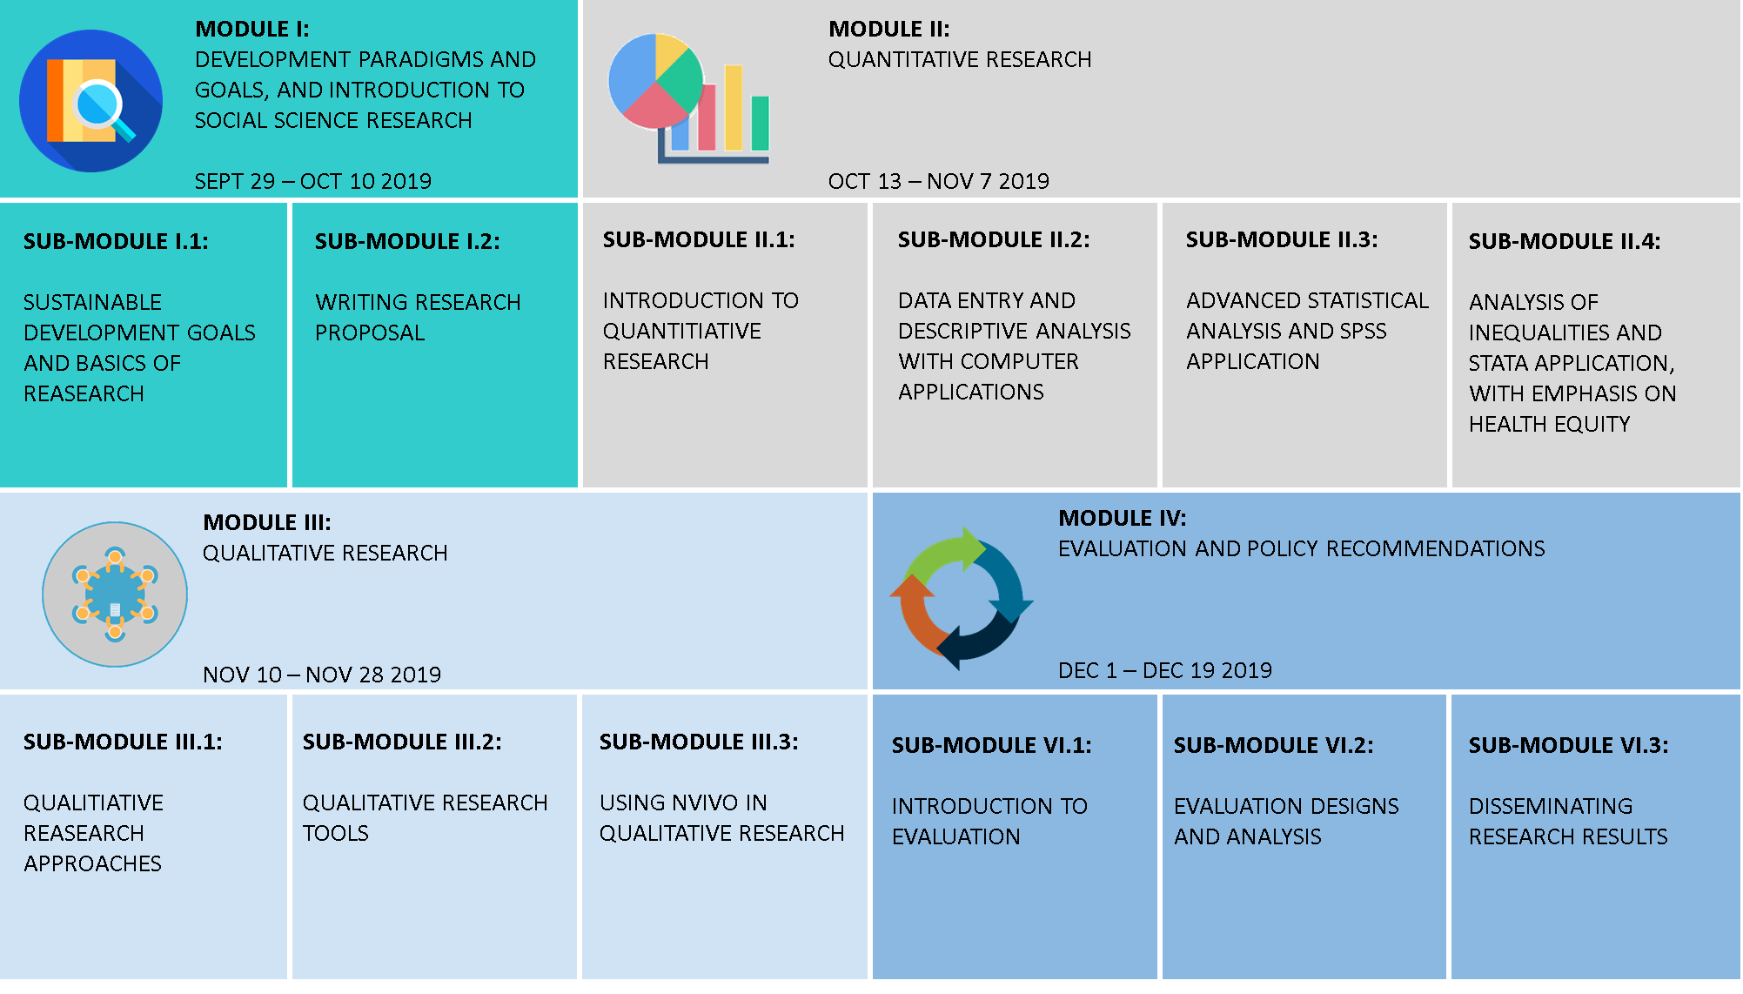

I. Personal Information
____________________________________________________________________________

- Full Name:

- Title: Choose an item.

- Sex: Choose an item.

- Date of birth: Day: Choose an item. Month Choose an item. Year Choose an item.

- Age in completed years:

- Address for correspondence:
Address:

Tel:
Mobile:
Fax:
Email:

- Nationality: Choose an item. If Others please specify

- Country of birth: Choose an item. If Others please specify

- Country of Residence: Choose an item. If Others please specify

- Current employment status: Choose an item.

II. Educational Background
___________________________________________________________________________

- In the table below, indicate the higher educational degrees (after secondary) you completed

Degree | Title | University | Year of Graduation

III. Professional Experience
___________________________________________________________________________

- In the table below, indicate the positions you held starting from the most recent

Title | Name and address of employer | Date

IV. Skills
___________________________________________________________________________

- Training: In the table below, please list any training you have received during the last five years in the field of research methods or evaluation

Title | Institution | Duration | Date
- Languages Proficiency: In the table below, please, rate your proficiency in Arabic and English languages

 | Speak | Read | Write
English | Choose an item. | Choose an item. | Choose an item.
Arabic | Choose an item. | Choose an item. | Choose an item.

- Computer Proficiency: In the table below, please rate your proficiency in using the following computer packages:

Computer package | Proficiency
Microsoft PowerPoint | Choose an item.
Microsoft Excel | Choose an item.
CSPRO | Choose an item.
SPSS | Choose an item.
STATA | Choose an item.
NVIVO | Choose an item.
ENDNote | Choose an item.

- Research Experience: In the table below, please give information on your previous research experience

 |  | If Yes give details
Have you ever conducted fieldwork? | Choose an item.
Have you ever prepared a research proposal? | Choose an item.
Have you ever written a scientific research report? | Choose an item.
Have you ever written a policy brief? | Choose an item.
Have you ever published scientific papers in peer reviewed journal? | Choose an item.

V. Course Information
____________________________________________________________________________

- How did you hear about this training course?Choose an item.
If Others please specify

- Have you ever applied for a training course at SRC?Choose an item.

If yes, were you accepted?Choose an item.

If Yes, please specify:
Title: Year Scholarship: Choose an item.

- What are you applying for?Choose an item. (The full course costs US$3,500)

- If you are applying for modules, what is (are) the module(s) you want to attend?

 | Modules | Date | Fees (US $)
 | Module I: Development Paradigms and Goals, and Introduction to Social Science Research | Sept 29-Oct 10, 2019 | 650
 | Module II: Quantitative Research | Oct 13-Nov 7, 2019 | 1,200
 | Module III: Qualitative Research | Nov 10-Nov 28, 2019 | 900
 | Module IV: Evaluation and Policy Recommendations | Dec 1- 19, 2019 | 900

- If you are applying for submodules, what is (are) the submodule(s) you want to attend? (each sub module costs (US$325)

 | Modules | Date
 | Submodule I.1: Sustainable Development Goals and Basics of Research | Sept 29- Oct 3, 2019
 | Submodule I.2 Writing Research Proposal | Oct 6-10, 2019
 | Submodule II.1: Introduction to Quantitative Research | Oct 13-17, 2019
 | Submodule II.2: Data Entry and Analysis with Computer Applications | Oct 20-24, 2019
 | Submodule II.3: Advanced Statistics and SPSS Application | Oct 27-31, 2019
 | Submodule II.4: Analysis of Inequalities and STATA Application with Emphasis on Health Equity | Nov 3-7, 2019
 | Submodule III.1: Qualitative Research Approaches | Nov 10-14, 2019
 | Submodule III.2: Qualitative Research Tools | Nov 17-Nov 21, 2019
 | Submodule III.3: Using NVIVO in Qualitative Research | Nov 24-Nov 28, 2019
 | Submodule IV.1: introduction to Evaluation | Dec 1- 5, 2019
 | Submodule IV.2: Evaluation Designs and Analysis | Dec 8- 12, 2019
 | Submodule IV.3: Disseminating Research Results | Dec 15- 19, 2019

- Are you interested in registering in the Professional Diploma Degree, given that you should pass the course exams with a minimum of 60% in all exams and submit a thesis in the second semester. The diploma fee is US$750 in addition to the full course fee (US$3,500)? Choose an item.

- Limited partial fee waivers are offered by SRC on a highly competitive basis to Egyptian nationals. Do you want a partial fee waivers? Choose an item.

- Please explain below (50-200 words): how will you benefit from attending this training course, your future career objectives and how will this course help you achieve them?

____________________________________________________________________________

Thank you for your interest in our training course

Please return the completed application form, no later than July 20, 2019, by email to: rm@aucegypt.edu or fill out the application on our website http://www1.aucegypt.edu/src/rm/

____________________________________________________________________________

Applicant Signature: Date:

____________________________________________________________________________

